1 - Atlanta Botanical Gardens
1345 Piedmont Avenue, Atlanta GA 30309
(404) 876 – 5859
https://atlantabg.org
2 - World of Coca Cola
121 Baker Street NW, Atlanta, GA 30313

(404) 676 – 5151
(800) 676 – COKE (2653)
https://www.worldofcoca-cola.com/
3 - The Krog (Market) District
99 Krog Street NE
Atlanta, GA 30307
https://www.thekrogdistrict.com/about

4 - Starlight Drive-in & Worlds Famous Flea Market
2000 Moreland Avenue SE, Atlanta GA 30316

Worlds Famous Flea Market
- Sat & Sun 6am – 3pm
- Free Parking
- 50 cents admission
https://starlightdrivein.com/

5 - The Martin Luther King, Jr. National Historical Park &
Ebenezer Baptist Church
450 Auburn Avenue, NE, Atlanta, GA 30312-1525

Headquarters/Visitor Center
(404) 331 – 5190
https://www.nps.gov/malu/index.htm

6 - Georgia Aquarium
225 Baker St NW, Atlanta, GA 30313
(404) 581 – 4000
https://www.georgiaaquarium.org/

7 – Skyview Ferris Wheel
168 Luckie Street NW, Atlanta, GA
https://www.skyviewatlanta.com/

8 - Busy Bee Cafe
810 Martin Luther King Junior Drive Southwest, , GA 30314
(404) 525 – 9212
https://www.thebusybeecafe.com/

9- Piedmont Park

400 Park Drive NE, Atlanta GA 30306

(Best GPS address: 1320 Monroe Drive, Atlanta, GA 30306)
https://piedmontpark.org/

10- Margaret Mitchell House and Museum

(where Gone in the Wind was wrote – verify if open)
979 Crescent Ave NE, Atlanta, GA 30309
Phone: (404) 249 – 7015

11 – Woodruff Park Playground “ATL” structure
91 Peachtree St, Atlanta, GA 30303
(404) 546 – 6744 or (404) 658 – 1877
atlantadowntown.com/go/woodruff-park

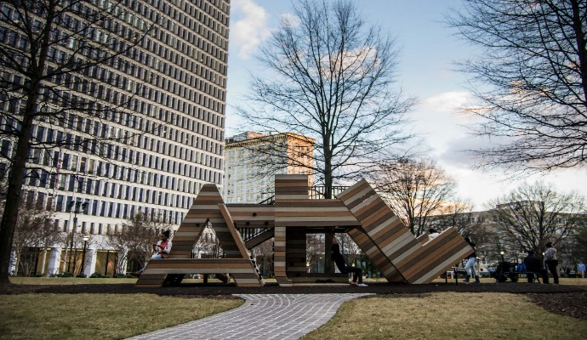

12 - CNN
190 Marietta St NW, Atlanta, GA 30313
(877) 4CNNTOUR / (404)827 – 2300 / Email: stour@tuner.com
(Tours maybe closed)
http://www.cnn.com/StudioTour/thanks.html

13 - Atlanta Zoo
Grant Park
800 Cherokee Ave SE, Atlanta, GA 30315
(404) 624 – 5600
https://zooatlanta.org/
14 - Colony Square Mall
(Giant size colorful ”MIDTOWN’ signage may still there for pictures on 15th Street and Peachtree)
1197 Peachtree Street NE, Atlanta 30361
(404) 965 – 9091
https://colonysquare.com/

15 -Underground –
50 Upper Alabama St, Atlanta, GA 30303
https://www.undergroundatl.com/

16 - Centennial Olympic Park –
Centennial Olympic Park Dr Atlanta, GA 30313
(In front of side entrance to CNN Center.)
(404) 223 – 4412
https://www.gwcca.org/centennial-olympic-park

17 - FOX Theatre –
660 Peachtree St NE, Atlanta, GA 30308
(404) 881 – 2100
https://www.foxtheatre.org/

18 - Tyler Perry “Madea House”
Photo opportunity - every Tyler Perry "Madea" film.
1197 Avon Ave SW, Atlanta, GA 30310
http://tours.lucentcreations.com/public/vtour/display/1353668?a=1#!/

19 - Tyler Perry Studio
315 Deshler St SW, Atlanta, GA 30310 (Tours are pending a request)
(678) 500 – 3710
https://tylerperrystudios.com/

20 - Truist Park at The Battery Atlanta
755 Battery Ave SE, Atlanta, GA 30339
(404) 577 – 9100
https://www.mlb.com/braves/ballpark/information

21 - Hard Rock Café Atlanta
215 Peachtree St NE, Atlanta, GA 30303
(404) 688 – 7625
https://www.hardrockcafe.com/location/atlanta/

22 - Lenox Mall &
3393 Peachtree Rd NE, Atlanta, GA 30326
(404) 233 – 6767
https://www.simon.com/mall/lenox-square

Phipps Plaza
3500 Peachtree Rd NE, Atlanta, GA 30326
(404) 262 – 0992
https://www.simon.com/mall/phipps-plaza

23 - College Football Hall of Fame
250 Marietta St NW, Atlanta, GA 30313
(404) 880 – 4800
https://www.cfbhall.com/

24 - Trap House Trap Music Museum
630 Travis Street NW, Atlanta GA 30318
(404) 277 – 8501
https://trapmusicmuseum.com/

25 - Children’s Museum of Atlanta
275 Centennial Olympic Park Dr NW, Atlanta, GA 30313
(404) 659 – 5437
https://childrensmuseumatlanta.org/

26 - David J. Spencer CDC Museum
1600 Clifton Rd, Atlanta, GA 30329
(404) 639 – 0830
https://www.cdc.gov/museum/

27 - Delta Flight Museum
1060 Delta Blvd, Atlanta, GA 30354
(404) 715 – 7886
https://www.deltamuseum.org/

28 - Federal Reserve Bank
1000 Peachtree St NE, Atlanta, GA 30309
(404 498 – 8500
https://www.atlantafed.org/

29 - Fernbank Museum of Natural History
767 Clifton Rd, Atlanta, GA 30307
(404) 929 – 6300
https://www.fernbankmuseum.org/

30 - High Museum of Art
The Woodruff Arts Center
1280 Peachtree St NE, Atlanta, GA 30309
(404) 733 – 4400
https://www.high.org/

31 - The Hammonds House Museum
503 Peeples St SW, Atlanta, GA 30310
(404) 612 – 0481
https://www.hammondshouse.org/

32 - JIMMY CARTER PRESIDENTIAL LIBRARY & MUSEUM
Freedom Park
441 John Lewis Freedom Pkwy NE, Atlanta, GA 30307
(404) 865 – 7100
https://www.jimmycarterlibrary.gov/

33 - MICHAEL C. CARLOS MUSEUM
Emory University
571 South Kilgo Cir NE, Atlanta, GA 30322
(404) 727 – 4282
https://carlos.emory.edu/

34 - Prince of Wales’s Olympics Monument –
World Athletes Monument
Pershing Point Park (Pershing Point Memorial Park ) in Midtown Atlanta, Georgia
Peachtree St NE, Atlanta, GA 30309
Intersection of Peachtree Street and West Peachtree Street.
https://www.thenmf.org/projects/monuments

35 - Atlanta History Center – Swan House
130 W Paces Ferry Rd NW, Atlanta, GA 30305
(404) 814 – 4000
https://www.atlantahistorycenter.com/
36 - Millennium Gate Museum – Atlantic Station
395 17th Street NW, Atlanta, GA 30363
(404) 881 – 0900
https://www.thegatemuseum.org/

37- Stone Mountain Park
1000 Robert E Lee Blvd, Stone Mountain, GA 30083
(770) 498 – 5690
https://stonemountainpark.com/

38 - LEGO Discovery Center Atlanta
3500 Peachtree Rd NE Suite G-1, Atlanta, GA 30326
(404) 848 – 9252
https://www.legodiscoverycenter.com/

39 - Center for Puppetry Arts
1404 Spring Street, NW at 18th, Atlanta, GA 30309-2820
(44) 873 – 3391
https://puppet.org/

40 - Skyline Park
The Rooftop at Ponce City Market
675 Ponce De Leon Avenue Northeast, Atlanta, GA 30308
(770) 999 – 1530
https://poncecityroof.com/

41 - Six Flags Over Georgia
275 Riverside Pkwy, Austell, GA 30168
(770) 739 – 3400
https://www.sixflags.com/overgeorgia

42 - Six Flags White Water
250 Cobb Pkwy N, Marietta, GA 30062
(770) 590 – 4067
https://www.sixflags.com/

43 - Atlanta Murals and Street Art Locations
https://findmasa.com/city/atlanta/2

44 - Atlanta Beltline Inc. (ABI)
Includes: Parks, Trails, Art, Urban Farm, Tours, Fitness, etc.
(404) 477 – 3003
https://beltline.org/

